**Group: A**

1. Unit of computer capable of performing arithmetic, logical and data manipulation operation on binary numbers is called
   1. CU
   2. **ALU**
   3. I/O units
   4. Processing Unit
2. Arithmetic logic unit

I. perform arithmetic operations

II. store data

III. perform comparison

IV. communicate with input devices

From above Correct one is.

* 1. I only
  2. II only
  3. I and II only
  4. **I and III only**

1. Which of the following is component of ALU?
   1. Functional Unit
   2. Multiplexor
   3. Instruction Decoder
   4. **All of the Above**
2. Operations of Computer Arithmetic and logic unit is directed by
   1. ALU itself
   2. Program
   3. **Control Unit**
   4. Memory Unit
3. An arithmetic logic unit (ALU) is a _______________ digital electronic circuit.
   1. **Combinational**
   2. Sequential
   3. Both
   4. None of above
4. Engineering design of arithmetic logic unit determines the
   1. Type and number of storing operations
   2. Type and number of logical operations
   3. Type and number of control operations
   4. **Type and number of logical and arithmetic operations**
5. Which is the function of Decoder?
   1. Perform logic and arithmetic operation
   2. **Selects the output we want from ALU**
   3. Send output choice made through the decoder
   4. None of the above
6. Which of the following is the function of Multiplexor?
   1. Perform logic and arithmetic operation
   2. Selects the output we want from ALU
   3. **Send output choice made through the decoder**
   4. None of the above
7. Both addition and subtraction can be performed by a single circuit using ____________
   1. Multiplexor
   2. **Controlled Inversion**
   3. Half Adder
   4. Fuller Adder

Group B

1. Design a combinational Logic circuit that selects and generates any of the following logic and arithmetic functions listed below.

A XOR B

A NOR B

A + B

A – B

Answer: 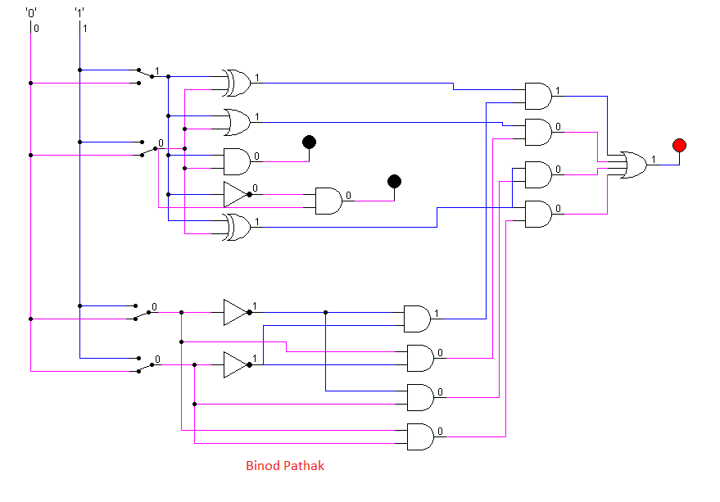

1. Design a digital circuit that performs the four logical operations of exclusive-OR, NOR, NAND and OR. Use two selection variables. Show the logic diagram of one typical stage. Discuss the working mechanism of the circuit that you have constructed.

**Answer:**  When i1 and i2 in the decoder in the following figure are both 0, d1 is 1 and the output is 0. When i1 is high or 1 and i2 is low or 0, d2 produces the value 1 as its output. Similar to this, when i1 is low or 0 and i2 is high or 1, d3 is also high or 1 and the result is 1. Finally, output is either 0 or low when both i1 and i2 are high or when 1 becomes high.

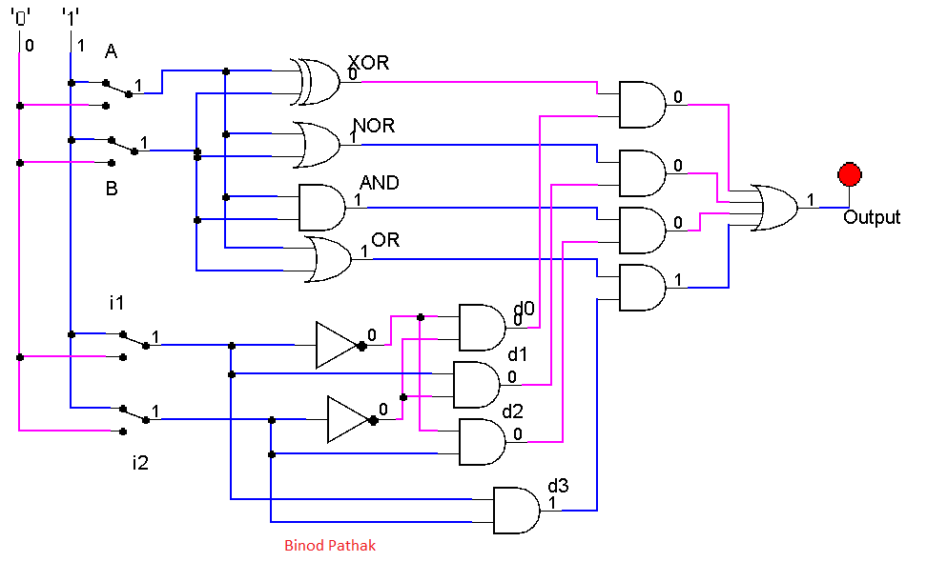

1. Following diagram shows a 4 bit adder/subtractor. Design the circuit diagram using Logsim. Discuss how the circuit performs addition and subtraction.

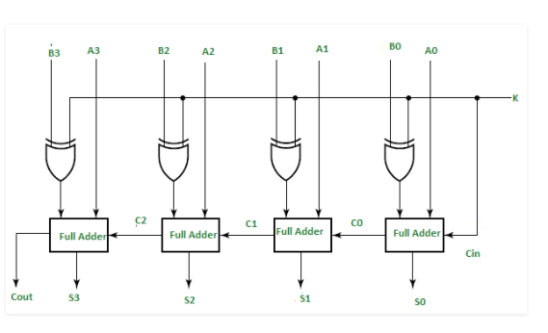

**Answer:** 